CENTRAL OKLAHOMA MOPAR ASSOCIATION
(COMA)

2018 All-MOPAR Car Show Sponsorship Package
“MOPARS 4 VETS”

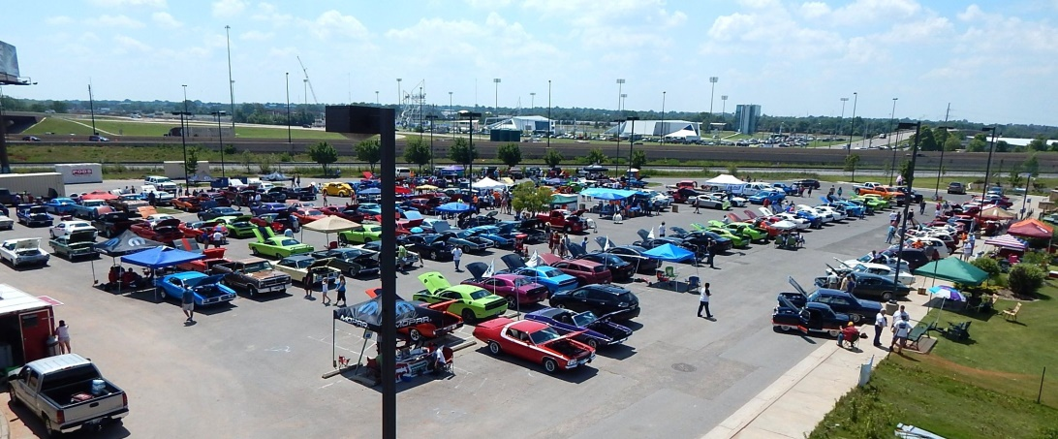

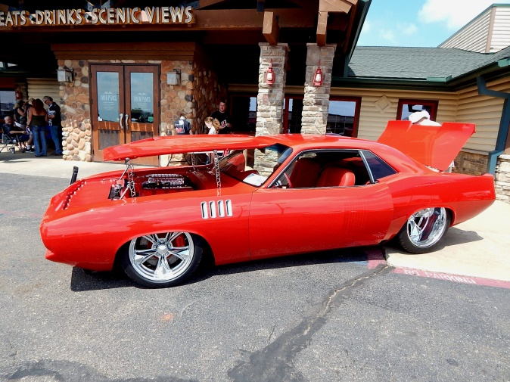

2015 “MOPARS ON THE RIVER”
at Bass Pro Shop in South Bricktown

2018 “MOPARs at the PEAKS”
“Best of Show”

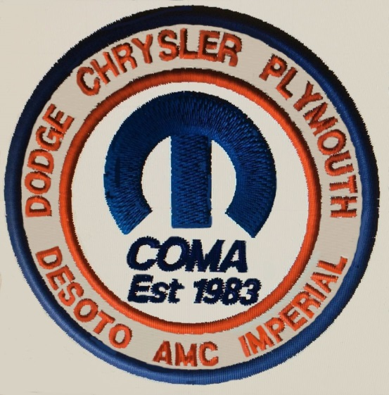

MOPAR SHOW CO-SPONSORSHIP PACKAGE

Show Host: Central Oklahoma MOPAR Association (C.O.M.A.).

The Show: C.O.M.A. will be hosting its 35th annual All-American MOPAR Event as, “MOPARS 4 VETS”, June 9, 2018, at the covered parking lot at the VA Hospital, 921 NE 13th Street, Oklahoma City, OK 73104. The actual parking lot is the new covered lot on the North side of the Hospital, off of N. Kelly Avenue. The show will be open to all makes of new and classic Chrysler (MOPAR) and Fiat vehicles. MOPAR owners from the Tri-State area are expected to join in this fun day.
** And you, as a sponsor are invited to join in this family event benefitting our military veterans.

About C.O.M.A.: The Central Oklahoma MOPAR Association was founded in 1983 with the goal of being a resource for car collectors, enthusiasts, and the community in regard to sharing knowledge about the restoration and preservation of MOPAR (Chrysler Corporation) vehicles. The Club in its secondary mission assists local and national charities with fundraising throughout the year.

About Sponsorship: C.O.M.A. is seeking Oklahoma City area businesses and donors to participate by helping underwrite the operational cost of this community fundraising event. Viewing of the cars in this event is open and free to the public, and will provide sponsors the opportunity to advertise their products and/or services to a wide spectrum of potential customers. Car Show Sponsorship can be in the form of cash, merchandise value, services, or a combination thereof.

Events sponsors will be providing general financial assistance to C.O.M.A. that will be used specifically for car show purposes, such as rental of venue/location of show, required city permits, additional vicarious liability insurance, trophies or plaques for show winners, tee shirts for show participants, advertising, dash plaques, trash removal, and other various show related expenses. The recommended levels of Sponsorship are as follows.

Sponsorship Levels:
Diamond Level - $1,000 or more
Platinum - $750 to $999
Gold - $500 to 749
Silver - $250 to 499
Bronze - $100 to 249

C.O.M.A.’s Charitable History: As in the past, a significant portion of this year’s event proceeds will go to charities. C.O.M.A. has assisted many non-profit organizations in the past including Ally’s House, the Jesus House, The Hugs Project, Susan B, Komen Breast Cancer Foundation, The YMCA’s “Our Sister’s Closet”, the Oklahoma Chapter of Make-A-Wish Foundation, the 45th Infantry Museum, Millard Fillmore Elementary School, and the Veteran’s Administration Hospital Volunteer Services Program.

This Year’s Charities: The Oklahoma City VA Hospital Voluntary Services Office.
Your generous sponsorship will directly support the Oklahoma City VA Hospital Voluntary Services Office, which provides needy VA patients goods (such as toiletries and robes) and other services while at the Hospital.
Sincerely,
Patrick Dean, President, Central Oklahoma MOPAR Association (COMA)

General Responsibilities:

C.O.M.A.: Will assume all general responsibilities for the event, including planning, parking lot rental, event activities, and crowd and parking control in conjunction with the event.

Liability – Sponsors shall not be held liable for accidents or injuries that occur to registered car show participants or C.O.M.A. members or event staff on the parking lot premises of the event. Vendors or auto dealers are individually responsible for any accidents or injuries that result from commercial activities, sales, or demonstration use of their property or products at the show. C.O.M.A. will provide the appropriate vicarious liability for accidents or injuries incurred during the actual published event times, and for event activity only.

C.O.M.A. Will Provide to Sponsors:

1. Appropriate recognition in all popular media used to electronically advertise the event.

2. Name recognition: Business logos to be displayed on all Sponsor Slide Shows on COMA Web Page, and Facebook Pages.

3. Event parking spots: All sponsors may be offered an event parking spot to bring a car, or items of a vendor nature in the vendor’s area, in accordance with the support level detailed in the following pages. Platinum level sponsors will be offered two parking spots, including one for any dealer vehicles for sale or demo. Diamond level sponsors will be afforded higher level benefits than the previous, up to and including bringing their own tent, tables, and chairs for their personal use in vending or “staging” personnel.

4. Free Event tee shirt (s).

5. At least two contact persons for making car show arrangements.

Other:

1. Sponsors may provide C.O.M.A. with promotional materials or small items for the event participant’s “goodie bags”.

2. Sponsors are free to coordinate with the C.O.M.A. event co-chairmen in selecting and presenting a “(sponsor’s name) Choice” award trophy or plaque. The sponsor themselves should make this award selection.

3. Sponsors are free to coordinate with COMA on a one-to-one basis for any other arrangements at the car show.

4. Upon request, C.O.M.A. will provide sponsors a receipt or letter document their donation as a business expense for advertisement.

DIAMOND SPONSOR
______________________________________

What you get as a Diamond Sponsor:

- Trophy to be awarded on sponsor’s behalf.

- Sponsor’s name or business Logo on MOPAR Event tee shirt. This may be included in the event/show logo, if time permits.

- Two (2) 2017 C.O.M.A. honorary memberships. (two individual or one family membership)

- Three (3) MOPAR Event tee shirts. (Please advise your show contacts as to sizes desired)

- Sponsor’s name listed on C.O.M.A. web page and Facebook page for remainder of 2017.

- Sponsor will be noted in all 2017 events flyers, printed media ads, and club newsletters.

- Sponsor will receive a “Thank You” plaque from C.O.M.A.

- Sponsor may provide advertising banner to be displayed at the show event, and at all club meetings for 2017. (This is at sponsor’s option. Sponsor must provide the banner.)

PLATINUM SPONSOR
______________________________________

What you get as a Platinum Sponsor:

- Sponsor’s name listed on C.O.M.A. web page and Facebook page as event sponsor.

- Sponsor will be noted in all 2017 events flyers, printed media ads, and club publications. (Sponsor may provide their own logo)

- Trophy to be awarded on sponsor’s behalf.

- Sponsor may provide advertising banner to be displayed at the MOPAR event. (This is at sponsor’s option. Sponsor must provide banner.)

- One (1) 2017 C.O.M.A. honorary memberships. (individual or family)

- Two (2) MOPAR Event tee shirts. (Please advise your show contacts as to sizes desired)

GOLD SPONSOR
______________________________________

What you get as a Gold Sponsor:

- Sponsor’s name listed on C.O.M.A. web page and Facebook page as event sponsor.

- Sponsor will be noted in all 2017 events flyers, printed media ads, and club publications. (Sponsor may provide their own logo)

- Sponsor may provide advertising banner to be displayed at the MOPAR event. (This is at sponsor’s option. Sponsor must provide banner.)

- Two (2) MOPAR Event tee shirts. (Please advise your show contacts as to sizes desired)

SILVER SPONSOR
______________________________________

What you get as a Silver Sponsor:

- Sponsor’s name listed on C.O.M.A. web page and Facebook page as event sponsor.

- One (1) MOPAR Event tee shirt. (Please advise your show contacts as to sizes desired)

BRONZE SPONSOR
______________________________________

What you get as a Bronze Sponsor:

- Sponsor’s name listed on C.O.M.A. web page and Facebook page as event sponsor.

Central Oklahoma MOPAR Association

Contact Information

C.O.M.A. Club General Contact
E-Mail: www.okcmopars.org
Facebook: https://www.facebook.com/okcmopars/?ref=bookmarks

Mailing Address: Central Oklahoma MOPAR Association
P.O. Box 96061
Oklahoma City, OK 73124

C.O.M.A. President: Patrick Dean
E-Mail: Bigblockguy1@hotmail.com
Mobile: 405-408-6274

Show Committee Contacts:

Frank Lipsinic, Col, USAF Ret
Secretary, Webmaster, Show Co-Chairman
E-Mail: franklipsinic@cox.net
Mobile: 405-821-7343

Jim Sharp
COMA VP, and Show Co-Chair
E-Mail: jsharp43@cox.net

Doug Cataline, Show Committee
E-Mail: b707fe@gmail.com
Mobile: 405- 596-6513

